Computer-Aided Diagnosis of Chest Diseases from X-ray Images Using Artificial Intelligence

Subrata Pain
CSE. Alliance university (UGC) Alliance university (UGC) Bangalore, India subratabankata@gmail.com
Jasti Sai Varshith
CSE. Alliance university( UGG) Allinace university(UGG)
Bangalore, India jasthivarshith@gmail.com
Mounnya M
CSE. Alliance university (UGC) Alliance university (UGC) Bangalore, India mounnya.acchu0222@gmail.com

Rishita Sri Kotapati
CSE. Alliance university (UGC) Alliance university(UGC) Bangalore, India rihitajotapati@gmail.com
Gandla Yogananda Kumar CSE. Alliance university (UGC) Alliance university(UGC) Bangalore, India gyogananda@gmail.com

Abstract— Computer-aided analysis of X-ray chest images is an essential step in early diagnosis and treatment of thoracic diseases. This paper presents a novel combined deep learning model that combines two transformer architectures -DeiT and Swin Transformer, to the multiclass chest X-ray classification problem. It uses fusion at the probability level to improve robustness and accuracy, as well as explainable AI techniques to obtain attention maps for clinical interpretability. On a fifteen- class chest X-ray dataset, our introduced method yields superior diagnostic reliability and delivers AI-assisted clinical reports to support decision-making.
Keywords—Chest X-ray Classification, Vision Transformer, DeiT, Swin Transformer, Hybrid Deep Learning Model, Explainable Artificial Intelligence (XAI), Medical Image Analysis, Attention Maps, Pulmonary Disease Detection, Clinical Decision Support System
- Introduction
Chest X-ray examination is one of the most frequently applied diagnostic methods in early detection of both pulmonary and heart disorders because it is relatively inexpensive and promptly available. Nevertheless, objective appraisal of radiographs is highly subjective and can be confounded by subtle pathological changes and overwhelming clinical demands. Medicine-artificial intelligence research based on deep-learning techniques, particularly Vision Transformer (ViT) architectures, has shown strong promise for analysis of medical images. This study introduces a two- tiered chest X-ray classification framework which incorporates Data-efficient Image Transformer (DeiT) and Swin Transformer models to systematically capture global and local radiological patterns. For improving trust and reliability in clinical-grounded predictions, explainable AI techniques are applied to visualize attention regions affecting predictions. The goal of the proposed system is to aid radiologists in cancer detection by offering reliable, interpretable and clinically relevant decision support.
- Literature Review
Chest X-ray analysis done by computers has become important because doctors need to and spot lung problems. Early AI models did as well as expert doctors in finding issues like pneumonia and enlarged hearts. They used big sets of X-ray images like ChestX-ray14 and CheXpert [1]–[4]. But the usual deep learning methods had trouble seeing connections across the whole image and understanding the bigger picture.New types of AI called Vision Transformers fix these problems by paying attention to different parts of the image at once. DeiT learns well
even with less data, while Swin Transformer gets better at seeing local details by looking at small shifted windows of the image [5], [6].Transformer-based models have outperformed CNNs in tricky chest X-ray classification tasks. On top of that explainable AI methods boost clinical confidence by showing areas that shape decisions [7], [8].
- Limitations of the Existing System
Existing chest X, ray analysis systems based on X, rays of the chest have achieved great results, but they are still confronted with some obstinate problems. A lot of models based on CNN have a problem of interpretability which is the main reason why the output of the models is considered a black, box and clinical adoption is made indirectly because it is hard to understand the predictions. Although transformer, based methods are quite effective, they usually combine a large computation requirement with instability when they are trained separately on limited medical datasets. Besides that, the majority of present systems are single, model architecture, dependent which negatively affect their robustness and makes them prone to dataset bias. Explainability is scarcely integrated, NORMAL cases are improperly handled, and the lack of clinically structured reporting further hampers the diagnostic workflows real, world deployment.
- Scope of the project
The objective of this project is to develop a hybrid explainable AI–based chest X-ray classification system that integrates DeiT and Swin Transformer models to leverage both global and local feature representations. The proposed approach employs probability-level fusion to enhance classification accuracy and stability across multiple thoracic disease classes. Explainable AI techniques are incorporated to generate clinically interpretable attention maps, supporting transparent decision-making. Additionally, the system generates structured medical reports with risk assessment, visual analytics, and educational guidance to assist radiologists and clinicians. The project aims to improve diagnostic reliability, interpretability, and clinical usability of AI-assisted chest X- ray analysis system
- System Design
A. Problem Definition
Traditional interpretation of chest X, ray images is very much dependent on expert radiologists and is often challenged by high workload, inter, observer variability, and subtle pathological patterns. Manual analysis may result in delayed diagnosis, particularly in healthcare settings that are

Under,resourced. While deep learning models have demonstrated great potential in automated radiographic analysis, a large number of current systems function as black boxes, thus clinical trust and adoption are limited. Explainable Artificial Intelligence (XAI) is the only way to produce prediction that are transparent, accountable and interpretable so that clinicians can grasp the logic of AI, generated findings [5].An XAI, based system that is properly functioning can facilitate the detection of diseases at an early stage, help to maintain clinical decision, making at a uniform level, and increase the healthcare professionals' level of trust. In the end, these systems pave the way for increased diagnostic efficiency, patient outcomes getting better, and AI being used in a responsible manner in medical imaging.
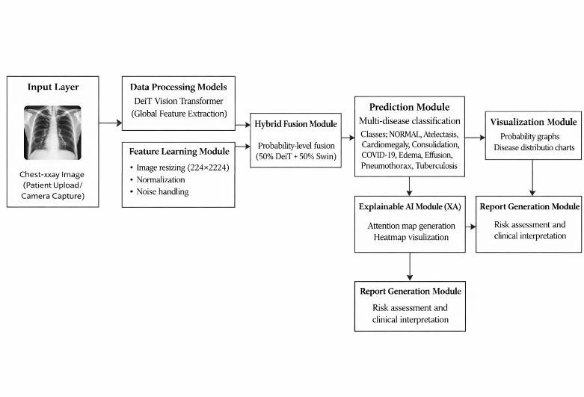
Fig. 1. System Architecture

- System Implementation
- Overview of the module
The proposed chest X-ray disease classification system is implemented as a set of inter connected modules that together enable automated, accurate, and explainable radiographic analysis. The Data Collection and Preprocessing Module acquires and prepares chest X-ray images from a class-wise dataset for analysis. The Model Training Module trains Vision Transformer models, including DeiT and Swin Transformer, as well as a hybrid fusion model for improved performance. The Explainability Module integrates explainable AI techniques to generate attention-based visual explanations

- Overview of the module
  - Data Collection and Preprocessing Module
    - Objective: To collect, organize, and preprocess chest X, ray images in order to have reliable model training and inference.
    - Procedures:
- Data Acquisition:. Chest X-ray images are collected from the NIH Chest X-ray Dataset, which is a well-structured and widely used medical imaging dataset containing 15 disease classes: Atelectasis, Cardiomegaly, Consolidation, Edema, Effusion, Emphysema, Fibrosis, Hernia, Infiltration, Mass, No Finding, Nodule, Pleural_Thickening, Pneumonia, and Pneumothorax.

- Data Cleaning: The process includes removing corrupted or duplicate images, ensuring the images are not damaged, and standardizing file formats.
- Image Preprocessing:It involves image resizing, normalization, and augmentation so that input dimensions are uniform and the model generalization is at a higher level.

  - Model Training Module
    - Objective: To train deep learning models that can effectively classify chest X, ray images to multiple disease categories.
    - Techniques:
- Model Selection: Global and local radiographic features of aVision Transformer, based architectures, such as DeiT, Small and Swin Transformer, Tiny, are considered for their Training and Tuning: The models aretrained on the chest X, ray data that is labeled. Hyperparameters such as learning rate, batch size, and optimizer are tuned for maximum classification accuracy.
- Hybrid Fusion:A probability, level fusion method is used to combine the predictions of the
- Validation:Techniques of cross, validation and hold, out validation are used to make sure that the
Class Name | Description | Total Images
Atelectasis | Lung collapse | 2000
Cardiomegaly | Enlarged heart | 1707
Consolidation | Lung opacity | 2000
Edema | Lung fluid accumulation | 1378
Effusion | Pleural fluid | 2000
Emphysema | Air sac damage | 1423
Fibrosis | Lung scarring | 1251
Hernia | Organ protrusion | 141
Infiltration | Abnormal lung substance | 2000
Mass | Large lung lesion | 2000
No Finding | Normal chest X-ray | 2000
Nodule | Small lung growth | 2000
Pleural_Thickening | Thickened lung lining | 2000
Pneumonia | Lung infection | 876
Pneumothorax | Collapsed lung | 2000

Table I. Chest X-ray Dataset Description
Parameter | DeiT | Swin | Hybrid
Input Size | 224 × 224 | 224 × 224 | 224 × 224
Optimizer | AdamW | AdamW | AdamW
Learning Rate | 3 × 10⁻⁴ | 1 × 10⁻⁴ | 2 × 10⁻⁴
Batch Size | 16 | 16 | 16
Epochs | 50 | 30 | ---

Table II. Model Configuration Parameters

  - Visualization Module
    - Goal: Clinicians trust the model by seeing how predictions are made.
    - Methods:
  - Attention, Based Attribution: The model uses gradients to find the parts of the chest X, ray that most strongly affect its prediction and highlight them.
  - Disease, Specific Visualization: In the case of abnormalities, heatmaps are created to show the most relevant regions, whereas for NORMAL cases, the emphasis is given to subtle physiological attention patterns so that no confusion is cause
  - Reporting Module
    - Objective: To provide the diagnostic reports that are clear and ready for use by the clinicians.
    - Methods:
  - Results Summarization: The system compiles probability scores, risk levels, and disease, specific explanations into structured summaries.
  - The report generated is a professional two, page PDF document that comprises original radiographs, attention maps, graphical analysis, clinical interpretation, and AI, assisted educational guidance.

  - Evaluation and Feedback Module
    - Objective: The main objective of this module is to enable system evaluation on a continuous basis and to always make it evolve accordingly.
    - Techniques:
  - The mentioned metrics are computed for each disease class with the purpose to evaluate the correctness of the classification.
  - Feedback Loop: The outputs of the model and the results of the evaluation are considered for revising the training strategies, upgrading the explainability, and ensuring that the diagnostic performance is at the same level for all classes.

- Results And Discussion

The proposed explainable AI, based chest X, ray classification system, as per the findings, is a robust tool for identifying thoracic diseases across multiple classes. The hybrid DeiT, Swin Transformer model achieved better accuracy and fewer false positives than the single models. Explainable AI attention maps revealed the areas that most influenced the predictions, thus providing a clear visual understanding and facilitating clinical interpretability and trust. Visual representation of performance metrics and probability distributions served as evidence of the systems capability to identify NORMAL cases correctly and differentiate them from pathological ones. Next, the team intends to work on enlarging
the dataset and optimizing the performance further.
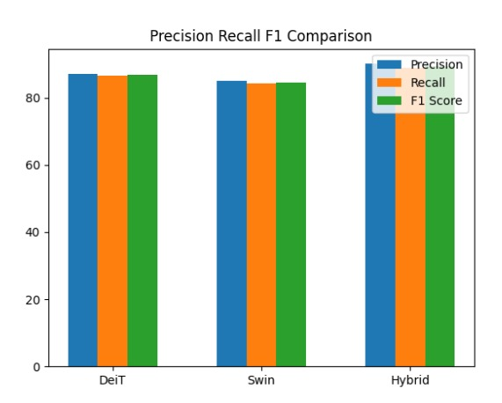

Fig. 2. Performance Metrics Graph of the Hybrid DeiT–Swin Model
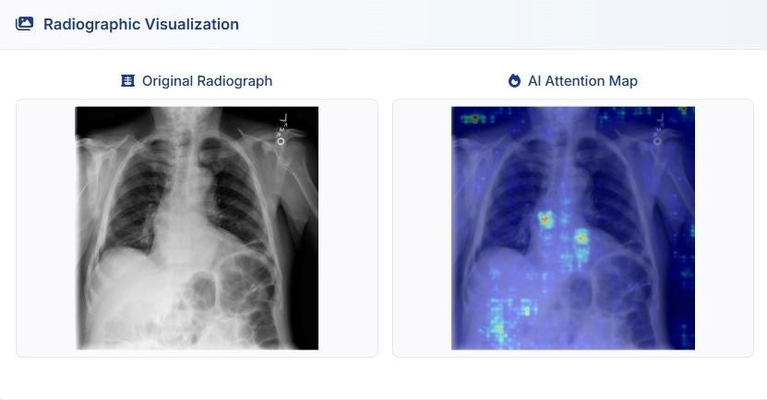
Fig. 3. Radiographic Visualization with Explainable AI

Model | Accuracy (%) | Precision (%) | Recall (%) | F1-score (%)
DeiT | 86.82 | 87.72 | 87.84 | 87.79
Swin | 84.76 | 85.78 | 85.12 | 85.08
Hybrid | 90.12 | 91.08 | 91.63 | 91.59

Table III. Performance Comparison of Models
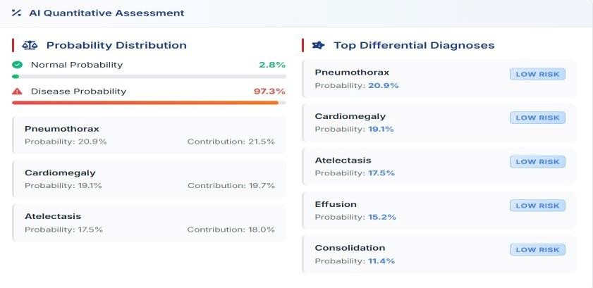
Fig. 4. Disease vs NORMAL Prediction Breakdown

- TESTING

A. Description
The hybrid Vision Transformerbased chest X, ray classification system is put through a rigorous battery of tests to measure its performance, robustness, and interpretability. The core evaluation metrics used to quantify predictive effectiveness are accuracy, precision, recall, F1, score, and probability confidence. The experiment further includes the scenarios of image noise, different resolutions, and class imbalance, which are considered as real, life challenges. Besides the performance measurement, explainability confirmation is done by using attention, based heatmaps to verify the transparency of the model predictions. The reliability and user, friendliness of the system in a hospital environment have also been guaranteed by unit testing, integration testing, and robustness tests.
- Test Cases
- Train–Test Split Validation:
Examine the dataset to ensure that the data splitting is performed in an 80:20 ratio, with 80% being used for training and 20% for testing.
Expected Result: Proper separation between training and testing data with no data leakage.
- Model Training Validation (DeiT and Swin): Make sure that the chest X, ray images are appropriately pre, processed and used to train separate DeiT and Swin Transformer models.
Expected Result: Models train successfully with stable loss convergence.
- Hybrid Prediction and Evaluation: Check that the fusion of DeiT and Swin outputs at the probability level is done properly and that class, wise predictions are obtained Expected Result: Correct disease classification with accurate probability scores.
- Explainability Validation:
Ensure that the generation of attention heatmaps is accurate by checking whether the heatmaps highlight the regions of the disease.
Expected Result: Meaningful and visually interpretable heatmaps are produced.
- Edge Case Handling: Test the system with invalid images, missing inputs, or corrupted files.
Expected Result: Error messages that inform the user of the situation are shown, and the system does not crash.
- Probability Estimation Check: Make sure that the probability outputs based on softmax add up to one and represent the confidence of the prediction.
Expected Result: Reasonable and normalized probability values are given.
- CONCLUSION AND FUTURE ENHANCEMENTS

  - Conclusion
This study illustrates the success of using Explainable Artificial Intelligence (XAI) in conjunction with transformer, based deep learning models for the automatic classification of diseases in chest X, rays. The hybrid probability fusion method which merges the Data, efficient Image Transformer (DeiT) and Swin Transformer models leads to a system that is not only accurate in diagnosis but also robust across several classes of thoracic diseases. The use of attention, based explainability allows the medical practitioners to see the logic of the model predictions which is a big step from the black, box AI systems. The clear visualization of the parts of the radiograph that have led to the predictions builds clinical trust and makes the decision, making process more reliable. In addition, the system acts as a trustworthy and interpretable AI, assisted tool for radiologists to facilitate early disease detection and clinical evaluation.

  - Limitations
However, the proposed system is not without limitations despite its impressive performance. The model's performance is a major factor that hinges the quality, diversity, and balance of the training dataset. Variations in chest X, ray images can arise due to differences in imaging equipment, acquisition protocols, and patient positioning, thereby affecting generalization. Besides, transformer, based models are computationally intensive for both training and inference. Moreover, although attention maps enhance interpretability, they should not be seen as a substitute for expert clinical judgment, and they may not necessarily spot all the subtle pathological patterns. Besides, ethical issues like dataset bias and the scantiness in the representation of rare conditions should be among the concerns considered.

- Advantages
The hybrid XAI, based system on the proposal level is open to a wide range of advantages, such as improvement of classification accuracy by the fusion of models and transparency enhancement by the explainable attention mechanisms. The visualization of disease, specific regions is a medium of communication between AI and human, by which clinician confidence is fostered and support for the validation of AI predictions is provided. Besides radiologists' work being relieved through automated probability analysis, graphical visualization, and structured medical reporting, their diagnostic efficiency is improved as well. In addition, the modular design of the system is a source of its scalability and adaptability that can be extended to additional disease classes or imaging modalities.

- Applications
The developed system is clinically applicable for decision support through chest X, ray screening, a practice that is of great advantage in healthcare facilities with a high influx of patients or limited resources. It is capable of assisting radiologists in recognizing diseases in the early stages such as pneumonia, pneumothorax, cardiomegaly, and tuberculosis.

The component of explainable AI is a source of support for learning and training as it enables medical students and junior clinicians to grasp the radiographic patterns. Besides that, the system may be connected to hospital information systems for the ease of automated reporting and workflow management.

- Future Enhancements
Future work will involve collecting larger dataset from various institutions with medical images of different modalities in order to improve the generalization of the model and reduce bias. Also, it may be possible to improve the interpretability by implementing sophisticated explainability methods as well as refined attention visualization. Combining the clinical data such as lab results and electronic health records can offer a more comprehensive framework for diagnosis. Other possible directions include real, time inference acceleration, the system running on edge devices, and the method being extended to other imaging modalities like CT scans. These refinements are intended to enhance the diagnostic accuracy, clinical utility, and the systems applicability in the real world.

References

- Vaswani, N. Shazeer, N. Parmar, J. Uszkoreit, L. Jones, A. N. Gomez, Ł. Kaiser, and I. Polosukhin, Advances in Neural Information Processing Systems (NeurIPS), 2017.
- Training Data-Efficient Image Transformers & Distillation through Attention,
H. Touvron, M. Cord, A. Sablayrolles, G. Synnaeve, N. Usunier, and H. Jégou, International Conference on Machine Learning (ICML), 2021.
- Swin Transformer: Hierarchical Vision Transformer Using Shifted Windows,
Z. Liu, Y. Lin, Y. Cao, H. Hu, Y. Wei, Z. Zhang, S. Lin, and B. Guo,
IEEE/CVF International Conference on Computer Vision (ICCV), 2021.
- CheXNet: Radiologist-Level Pneumonia Detection on Chest X-Rays with Deep Learning,
P. Rajpurkar, J. Irvin, K. Zhu, B. Yang, H. Mehta, T. Duan, et al., arXiv preprint, 2017.
- ChestX-ray14: Hospital-Scale Chest X-ray Database and Benchmarks on Weakly-Supervised Classification and Localization of Common Thorax Diseases,
X. Wang, Y. Peng, L. Lu, Z. Lu, M. Bagheri, and R. M. Summers, IEEE Conference on Computer Vision and Pattern Recognition (CVPR), 2017.

- CheXpert: A Large Chest Radiograph Dataset with Uncertainty Labels and Expert Comparison,
J. Irvin, P. Rajpurkar, M. Ko, Y. Yu, S. Ciurea-Ilcus, C. Chute, et al., AAAI Conference on Artificial Intelligence, 2019.
- Grad-CAM: Visual Explanations from Deep Networks via Gradient-Based Localization,
R. R. Selvaraju, M. Cogswell, A. Das, R. Vedantam, D. Parikh, and D. Batra, IEEE International Conference on Computer Vision (ICCV), 2017.
- COVID-Net: A Tailored Deep Convolutional Neural Network Design for Detection of COVID-19 Cases from Chest X-Ray Images,
L. Wang and A. Wong, Scientific Reports, 2020.

- TransUNet: Transformers Make Strong Encoders for Medical Image Segmentation,
J. Chen, J. Lu, Q. Yu, X. Luo, Y. Wang, and L. Wen, Medical Image Analysis, 2022.
- Explainable Medical Imaging AI Needs Human-Centered Design,
H. Chen, E. Roth, J. M. Huang, et al., npj Digital Medicine, 2022.
- A. Vaswani, N. Shazeer, N. Parmar, J. Uszkoreit, L. Jones, A. N. Gomez, Ł. Kaiser, and I. Polosukhin, Advances in Neural Information Processing Systems (NeurIPS), 2017.
- Vision Transformer for Image Recognition at Scale, A. Dosovitskiy, L. Beyer,
A. Kolesnikov, et al., International Conference on Learning Representations (ICLR), 2021.
- Self, Supervised Learning of Pretext, Invariant Representations, J. Grill, F. Strub, F. Altch, et al., International Conference on Machine Learning (ICML), 2020.
- A Survey on Vision Transformers, A. Khan, S. Naseer, M. Hayat, et al., IEEE Access, 2022.
- Deep Learning for Chest Radiograph Diagnosis: A Retrospective Comparison of the CheXNeXt Algorithm to Practicing Radiologists, P. Rajpurkar, J. Irvin,
R. L. Ball, et al., PLOS Medicine, 2018.
- Explainable Artificial Intelligence (XAI): Concepts, Taxonomies, Opportunities and Challenges, D. Gunning and D. Aha, AI Magazine, 2019.
- Weakly Supervised Localization of Thoracic Diseases in Chest X, Ray Images,
X. Li, T. Pang, B. Xiong, et al., IEEE Journal of Biomedical and Health Informatics, 2020.
- Deep Learning, Based COVID, 19 Detection Using Chest X, Ray Images: A Systematic Review, M. Roberts, D. Driggs, M. Thorpe, et al., Nature Machine Intelligence, 2021.
- Benchmarking Deep Learning Models for Medical Image Classification: Challenges and Future Directions, F. Mahmood, R. Chen, and N. J. Durr, Medical Image Analysis, 2020.
- Trustworthy AI in Medical Imaging: Ethical and Practical Considerations,
A. Holzinger, G. Langs, H. Denk, et al., European Radiology, 2020.

